This program will be a text adventure around the topic of

ASCII of a person sitting at a computer with an **ASCII Desktop**

It could contain different minigames that could be played

First you might load into a Menu, to select the mini-games like :

You launch into a game like minesweeper or tic tac toe

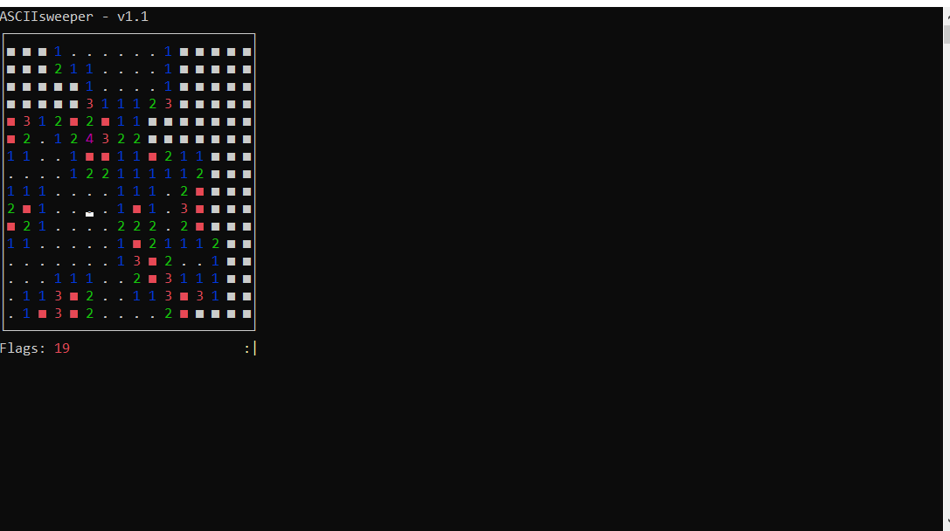

Depending on the outcome of the game, play an animation whether you won, drew or lost.

The story could change or revolve around results of games played

Some story for the game could be…

Could launch into a text adventure here

Finally play an ending animation:

Good Ending Ideas

Bad Ending Ideas

As the game concludes ASCII animation of the person getting killed.